**Adama Science and Technology University**

**School of Electrical Engineering and Computing**

**Department of Computer Science And Engineering**

**Database systems**

Database Project

Section 2,

Group members

Name Id

1.Bekam Genene ugr/30253/15

2.Begonet Debebe ugr/30244/15

3.Enderias Eshetu ugr/30469/15

4.kenenisa Beyan ugr/30772/15

5.Yeabsira Goitom ugr/31390/15

Instructor : Mr. Zena

Date : 25/09/2024

ETHIOPIANAIRLINE RESERVATION SYSTEM

**Introduction**

Welcome to the presentation of the Ethiopian Airlines Database System. This system is designed to manage the airline's flight, passenger, and payment information. The system is built using a relational database management system (RDBMS) and is designed to provide a user-friendly interface for airline staff to manage flight schedules, passenger bookings, and payments.

**Usage**

The system is used by airline staff to perform the following tasks:

* Manage flight schedules: Staff can add, update, and delete flight information, including flight numbers, departure and arrival times, and airplane details.
* Manage passenger bookings: Staff can add, update, and delete passenger information, including names, email addresses, phone numbers, and payment details.
* Manage payments: Staff can add, update, and delete payment information, including payment amounts, payment dates, and payment methods.

**Importance**

The Ethiopian Airlines Database System is important for the following reasons:

**Efficient Management**: The system provides a centralized platform for managing flight, passenger, and payment information, making it easier for staff to access and update information.

**Improved Customer Service**: The system enables staff to quickly retrieve passenger information and provide personalized service, improving the overall customer experience.

**Increased Revenue**: The system helps to reduce errors and improve payment processing, resulting in increased revenue for the airline.

**Conceptual Model**

The conceptual model of the Ethiopian Airlines Database System consists of the following entities:

**Airline**: The airline entity represents the airline company and its details, including name and country.

**Airplanes**: The airplanes entity represents the airplanes used by the airline and their details, including model and capacity.

**Flights**: The flights entity represents the flights operated by the airline and their details, including flight numbers, departure and arrival times, and airplane details.

**Passengers:** The passengers entity represents the passengers who book flights with the airline and their details, including names, email addresses, phone numbers, and payment details.

**Payments**: The payments entity represents the payments made by passengers and their details, including payment amounts, payment dates, and payment methods.

**The ER diagram for the Ethiopian Airlines Database System:**

**Entities**

* **Airline**
  + airline_id (primary key)
  + name
  + country
* **Airplanes**
  + airplane_id (primary key)
  + model
  + capacity
  + airline_id (foreign key referencing Airline)
* **Flights**
  + flight_id (primary key)
  + flight_number
  + departure_time
  + arrival_time
  + airplane_id (foreign key referencing Airplanes)
* **Passengers**
  + passenger_id (primary key)
  + first_name
  + last_name
  + email
  + phone_number
* **Payments**
  + payment_id (primary key)
  + amount
  + payment_date
  + passenger_id (foreign key referencing Passengers)
* **Reservations**
  + reservation_id (primary key)
  + flight_id (foreign key referencing Flights)
  + passenger_id (foreign key referencing Passengers)
  + payment_id (foreign key referencing Payments)
  + reservation_date

**Relationships**

* An airline can have multiple airplanes (one-to-many).
* An airplane can be assigned to multiple flights (one-to-many).
* A flight can have multiple passengers (one-to-many).
* A passenger can make multiple payments (one-to-many).
* A payment is associated with one passenger (many-to-one).
* A reservation is associated with one flight, one passenger, and one payment (many-to-one).

In diagram

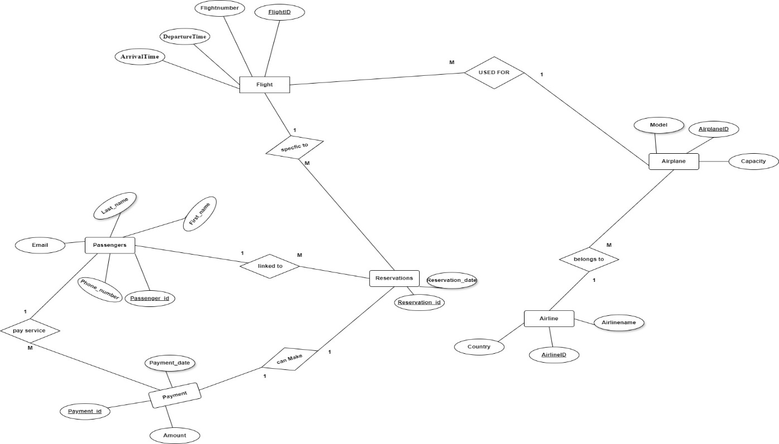

**Conclusion**

The Ethiopian Airlines Database System is a critical component of the airline's operations, providing a centralized platform for managing flight, passenger, and payment information. The system is designed to improve efficiency, customer service, revenue, and security, and is an essential tool for airline staff to perform their duties effectively.